# Instructions to create a New Project in CCSv10 for DSP TMS320F28379D

1. Creating a new Empty Project

File —> New —> CCS Project

Target: 2837xD Delfino TMS320F28379D

Connection: XDS100v2 USB Debug Probe

Project name: Any name without space, e.g., 2020_UTS_3p_inverter

Project templates and examples

Empty Project

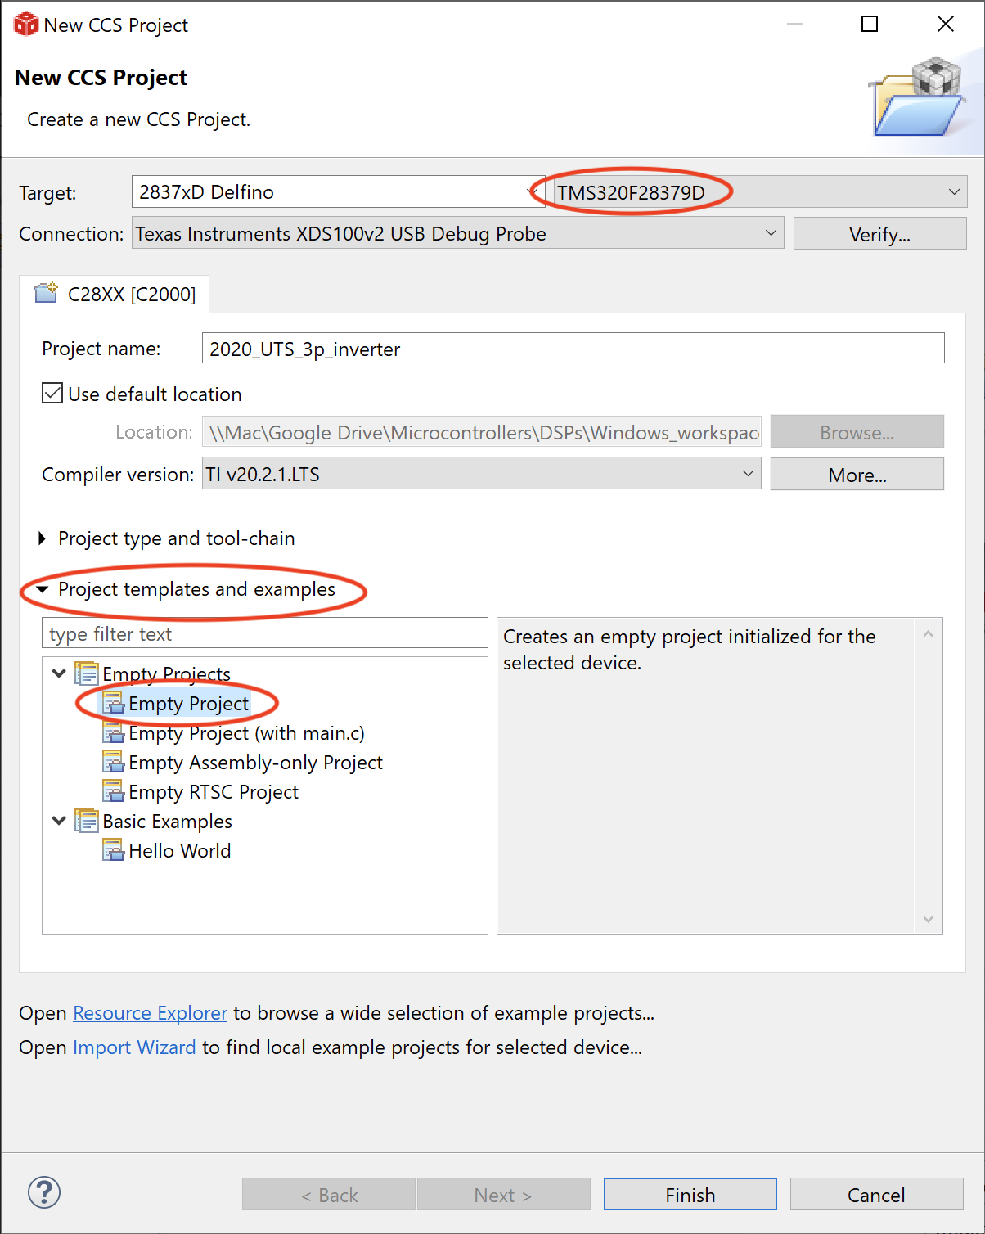

Project type and tool-chain

Linker command file: <none>

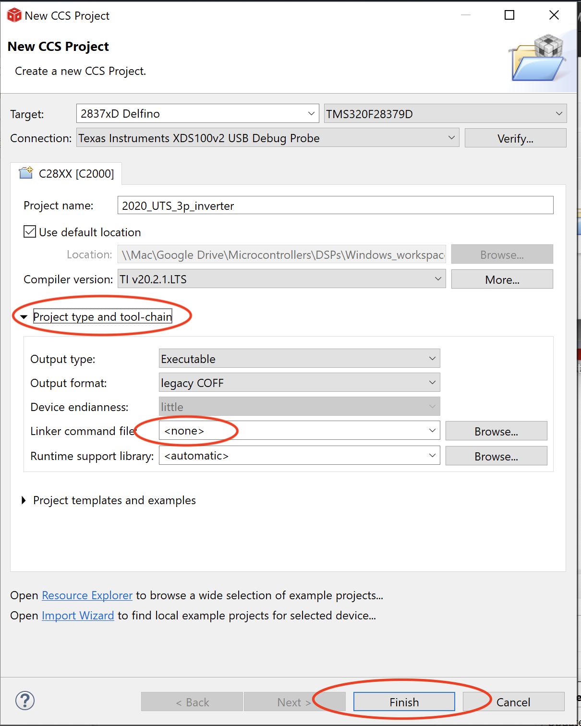

Then, finally click Finish.

2. Adding files to your project

Right click on your project,

Add Files,

Select all files in the folder UTS_F28379D/00_F28379D_Required_Files/AddFiles

then click Open

Then in File Operation, select Copy files and click OK.

Finally, follow the instructions in 00__2 Build Settings.rtf